**Title: Energy Skate Park: Basics**

**Introduction:**

In this lab, we are going to investigate potential, kinetic, and total energy. Potential Energy is stored energy. Kinetic Energy is the energy of motion.

**Important Questions:**

How do we determine the amount of potential and kinetic energy of an object?

How do we compare the measurements of two different types of energy?

How does the energy affect the speed and distance that the skater will move?

**Instructions:**

In this activity, the above questions are investigated. Complete this document by filling in data tables and writing complete responses. This investigation has three phases: Exploration, Explanation and Application. Work between this document and the simulation (sim).

1. Click this link: <https://phet.colorado.edu/en/simulation/energy-skate-park-basics>

This is a screen shot of the website:

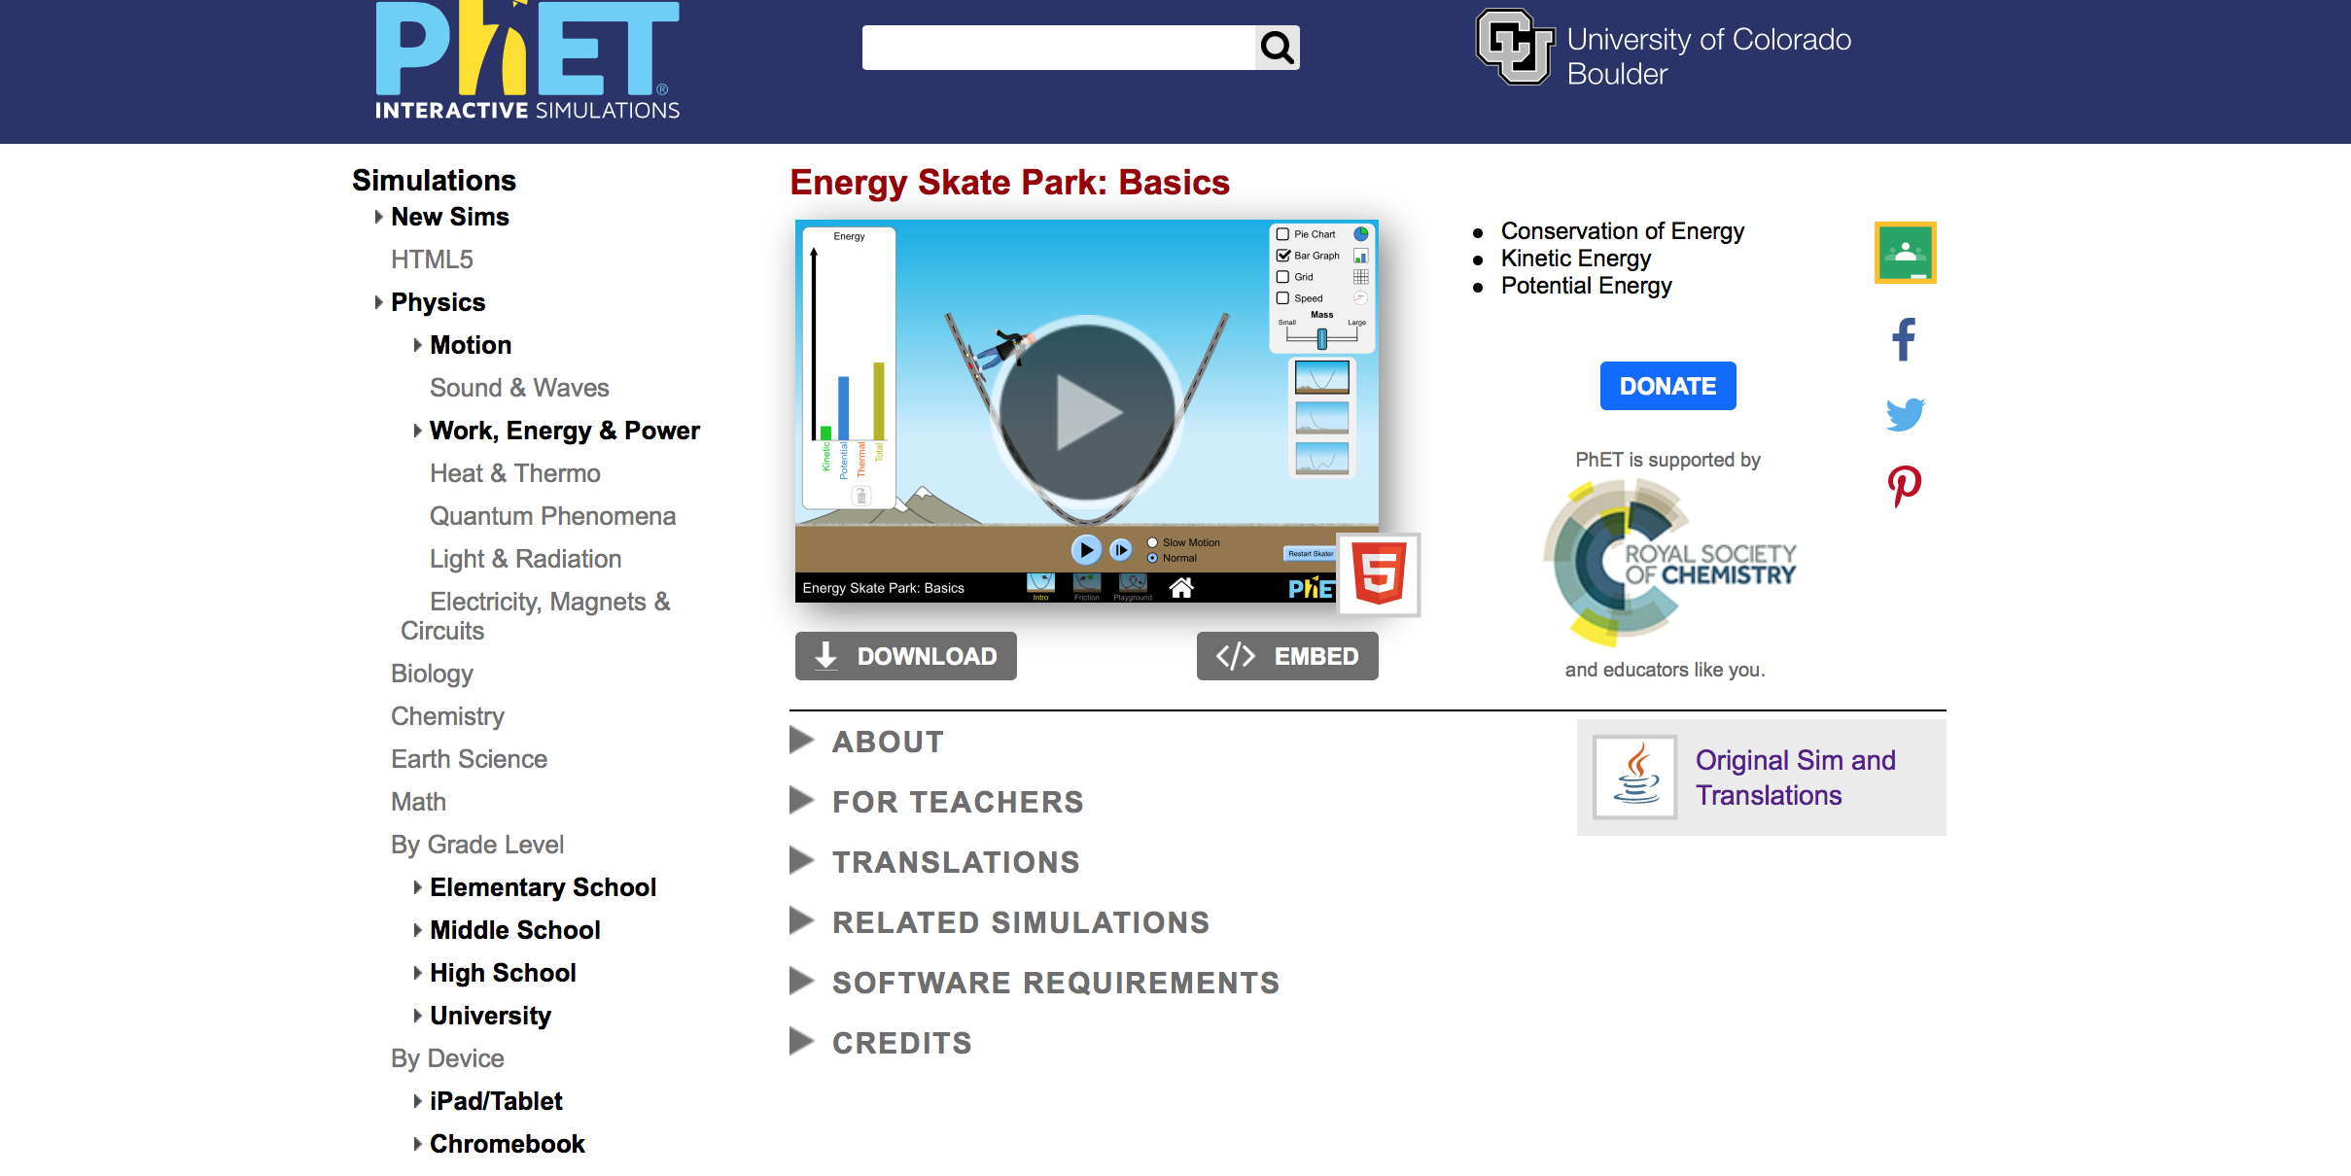

**If the link is not working type in https://phet.colorado.edu

a. Enter “Energy Skate Park: The Basics” in the search bar.

b. Find “Energy Skate Park: The Basics” and click the large start button.

2. This screen appears.

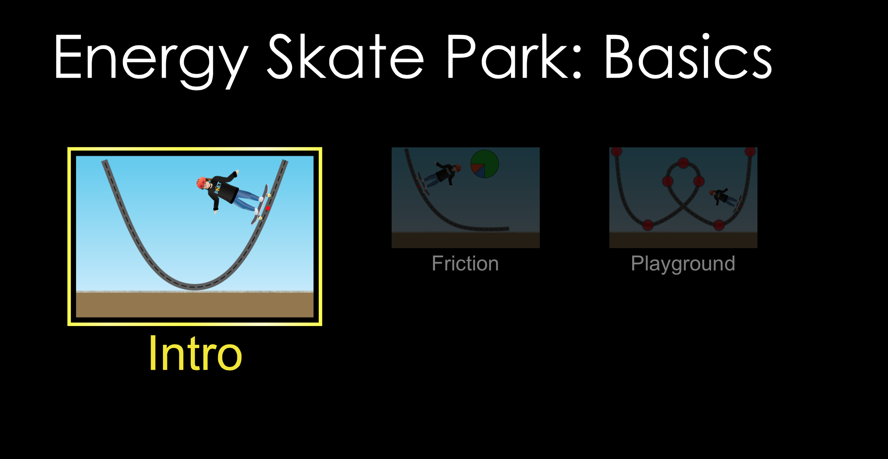

**Exploration Phase:**

**(5-7 minutes)**

1. Briefly explore this sim. Click the “Intro” tab.

2. Place the skater at various starting points on the ramp.

3. Explore changing his mass and the type of ramp.

4. Look at the variety of ways to display the data while the skater is moving.

5. Notice the reset button in the bottom right hand corner. It is orange with a white arrow.

6. There is also a button to restart the skater from the original position he was set up in.

**Explanation Phase:**

**(25-30 minutes)**

This Phase has an investigative goal.

*Aim: Create a rule for the amount of total energy versus the amount of potential and kinetic energy.*

**Hypothesis:** As the potential energy

Reset all of the setting that you have placed on the screen by clicking the orange button.

Your screen should look like this:

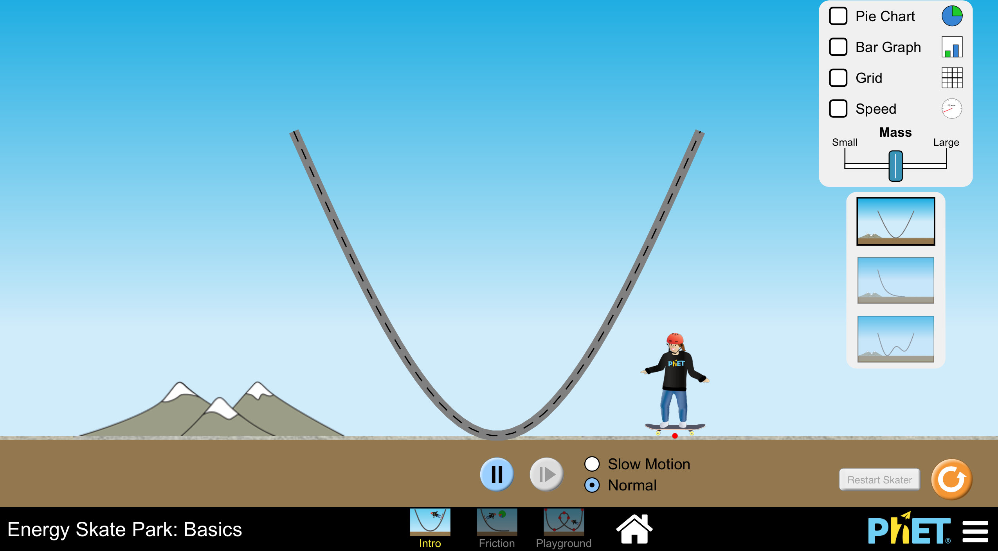

Select the box that says “Grid”

Use the ramp shaped like a U.

Select the box next to “bar graph.”

Your Screen should look like this without the letters:

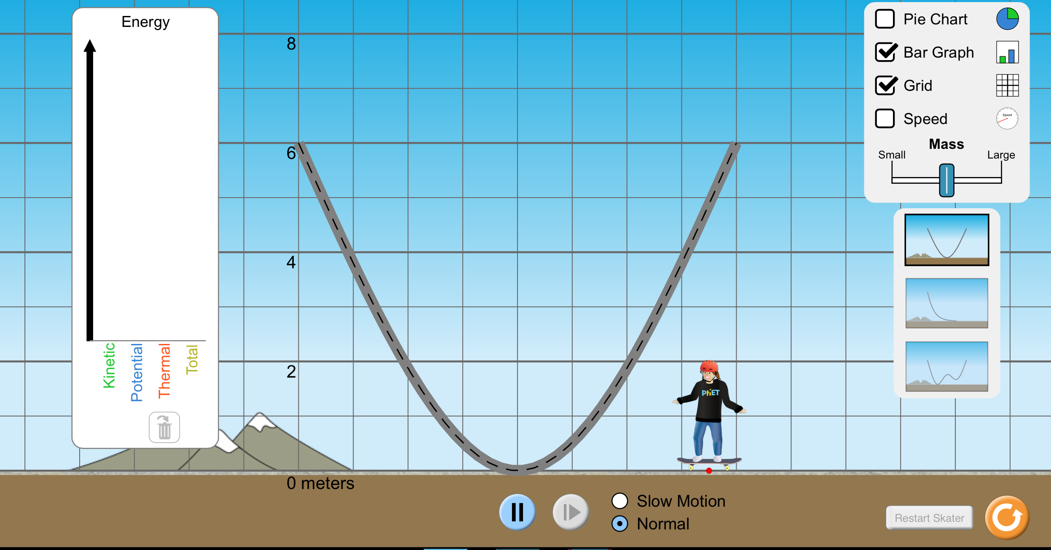

**C**

**B**

**D**

**A**

Directions:

1. On the top right corner there is a grey box with different types of tools used for collecting data. Click and make sure there is a check next to the speed meter and the pie graph.
2. Click the slow-motion option at the bottom to make it easier to see the change in the speed meter and the pie graph.
3. Click and drag the skater to the top of the ramp’s left side. Release the skateboarder.

Half-Pipe:

The first time, just watch prior to collecting data. Observe the changes of energy with the pie chart. After observing with the pie chart, observe the changes of energy on the bar graph (make sure there is a check).

**C**

**B**

**A**

Reset the Skater and be sure that the same data tools are being used.

In the table below, write down whether the quantity of potential, kinetic, and total energy *increases, decreases*, or *stays the same.*

|  |  |  |  |
| --- | --- | --- | --- |
| **Position** | **Potential Energy** | **Kinetic Energy** | **Total Energy** |
| **A** |  |  |  |
| **B** |  |  |  |
| **C** |  |  |  |
| **D** |  |  |  |

*Questions*

1. Where does the skater have the most potential energy?

_________________________________________________________________________________________

1. Where does the skater have the most kinetic energy?

_________________________________________________________________________________________

1. How does the mass of the skater affect the total amount of energy?

_________________________________________________________________________________________

Curved Ramp:

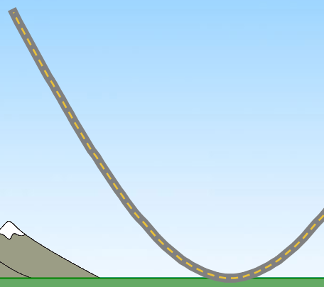

**A**

**B**

**C**

**D**

**E**

The first time, just watch prior to collecting data. Observe the changes of energy with the pie chart. After observing with the pie chart, observe the changes of energy on the bar graph (make sure there is a check).

**C**

**B**

**A**

Reset the Skater and be sure that the same data tools are being used.

In the table below, write down whether the quantity of potential, kinetic, and total energy *increases, decreases*, or *stays the same.*

|  |  |  |  |
| --- | --- | --- | --- |
| **Position** | **Potential Energy** | **Kinetic Energy** | **Total Energy** |
| **A** |  |  |  |
| **B** |  |  |  |
| **C** |  |  |  |
| **D** |  |  |  |

*Questions*

1. Where does the skater have the most potential energy?

_________________________________________________________________________________________

1. Where does the skater have the most kinetic energy?

_________________________________________________________________________________________

1. How does the mass of the skater affect the total amount of energy?

_________________________________________________________________________________________

Wavy Ramp:

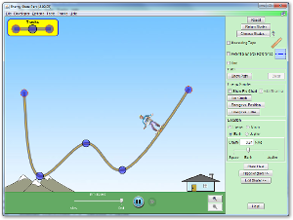

The first time, just watch prior to collecting data. Observe the changes of energy with the pie chart. After observing with the pie chart, observe the changes of energy on the bar graph (make sure there is a check).

**C**

**B**

**A**

Reset the Skater and be sure that the same data tools are being used.

In the table below, write down whether the quantity of potential, kinetic, and total energy *increases, decreases*, or *stays the same.*

|  |  |  |  |
| --- | --- | --- | --- |
| **Position** | **Potential Energy** | **Kinetic Energy** | **Total Energy** |
| **A** |  |  |  |
| **B** |  |  |  |
| **C** |  |  |  |
| **D** |  |  |  |
| **E** |  |  |  |

*Questions*

1. Where does the skater have the most potential energy?

_________________________________________________________________________________________

1. Where does the skater have the most kinetic energy?

_________________________________________________________________________________________

1. How does the mass of the skater affect the total amount of energy?

_________________________________________________________________________________________

Conclusion:

As the speed increases, how does the potential, kinetic, and total energy levels change?

_________________________________________________________________________________________________

_________________________________________________________________________________________________

_________________________________________________________________________________________________

_________________________________________________________________________________________________

_________________________________________________________________________________________________

Compare and contrast the energy levels on the half-pipe, the curved ramp, and the wavy ramp. What were the similarities or differences between the potential, kinetic and the total energies on these three ramps?

_________________________________________________________________________________________________

_________________________________________________________________________________________________

_________________________________________________________________________________________________

_________________________________________________________________________________________________

**Application:**

1. Now that you know a little bit about potential and kinetic energy, you are going to get your creative juices flowing.

2. You are going to go to the tab on the bottom that says “playground” and create your own ramp and test the kinetic and potential energy.

3. Make multiple different versions and see if you can change the maximum amount of energy that your ramp has.

4. Choose one of the ramps that you have created. Post a picture or our Google classroom and tell us where the skater has the most potential energy and the most kinetic energy.